## Assignment: 4

**Exp 1: WAP for printing Fibonacci sequence. Take input from the user to print up to a certain limit.**

Coding:

#include <stdio.h>

void fi(int);

int main()

{

    //nt= nextterm

  int n;

  printf("Enter a +ve number: ");

  scanf("%d", &n);

  fi(n);

  return 0;

}

void fi(int size)

{

    int t1 = 0, t2 = 1, nt = 0;

    printf("Fibonacci Series: %d, %d, ", t1, t2);

    nt = t1 + t2;

    while (nt <= size)

  {

    printf("%d, ", nt);

    t1 = t2;

    t2 = nt;

    nt = t1 + t2;

  }

}

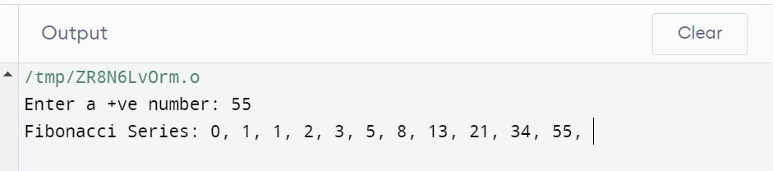

**Exp 2: WAP to swap two variables without using a third variable, depict the same using call by value concept.**

Coding:

#include <stdio.h>

void swap(int , int);

int main()

{

    int a;

    int b;

    printf("Enter a valid number");

    scanf("%d%d", &a,&b);

    swap(a,b);

}

void swap (int a, int b)

{

    int temp;

    temp = a;

    a=b;

    b=temp;

    printf("After swapping values in function a = %d, b = %d\n",a,b);

}

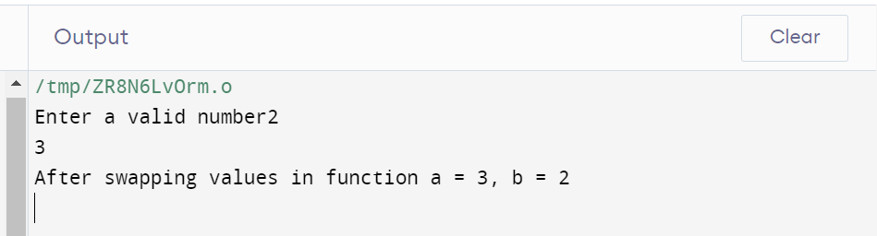

**Exp 3: A positive integer is entered through the keyboard. Write a Function to print the prime factors of this number.**

Coding:

#include<stdio.h>

int isprime(int val){

int flag=1;

if(val!=2&&val%2==0)

return flag=0;

if(val==2||val==3)

return flag=1;

for(int i=2;i<val/2;i++){

if(val%i==0)

flag=0;

}

return flag;

}

void primefactor(int num){

int n=num,i=2;

while(num!=1){

if(num%i==0){

if(isprime(i)){

printf("%d, ",i);

num=num/i;

}

}

else{

i++;

}

}

}

int main(){

int num;

printf("Enter a value: ");

scanf("%d",&num);

primefactor(num);

}

Output: 